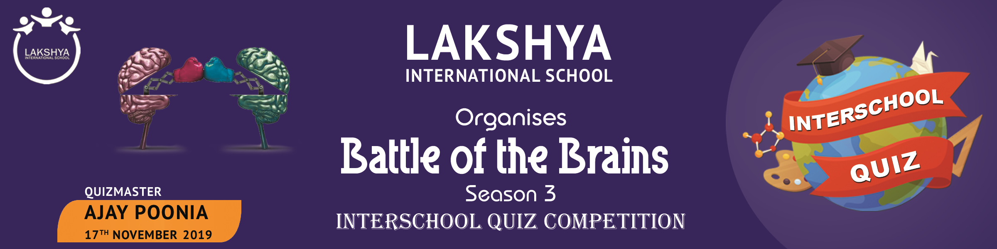

To
The Principal
____________________

Subject:- INVITATION FOR “BATTLE OF THE BRAINS–Season 3–INTER SCHOOL QUIZ 17th Nov’ 19
Dear Sir / Ma’am,

Greetings from Lakshya International School !!!

We are glad to announce and invite “you and your school” to participate in “Battle of the Brains – Season 3–Inter School Quiz -2019 scheduled on 17th Nov ’2019 (Sunday ). The Quiz will be held at the Lakshya Campus.

It is an excellent opportunity for your students to apply their lessons from the classroom to a real world situation.

The Contest will be conducted by a professional Quiz Master Mr. Ajay Poonia
An Information sheet regarding Battle of the Brains- Season 3 Inter School Quiz Competition is attached for your information.
In the first instance, we would be grateful if you could confirm your participation in the event by completing the attached Registration Form with all necessary details and send it at info@lakshyaschool.in (Last date of confirmation is 10th November’ 2019).

In the meantime, if you require any help or further information, please contact the Organizing Committee Ms. N. Priyadarshini @ 8096196664 and Ms. G. Sailaja @ 9133657007

Yours sincerely

Satyaki Banerjee
Head of School
A SNAPSHOT OF “BATTLE OF BRAINS” Season 3

- Date of Event:-- 17th November 2019
- Venue:-- Lakshya International School Auditorium , Unduru , Kakinada.
- Registration Fees :-- Rs 250 per team (For example 2 teams from one school means Rs. 500)
Schedule:
GROUP A  G – IV to VI | Registration time | 8:15–9:20 A.M | Group B  G – VII to X | Registration time | 10:00 – 11:00 A.M
 | Prelims | 9:30-10:15 A.M |  | Prelims | 11:00 – 12:00 Noon
 | Prelims Results | 10:30 A.M |  | Prelims Results | 12:15 P.M
 | Finals | 11:00–12:45 P.M |  | Finals | 2:00 – 4:00 P.M
 | Prize distribution | 1:00-1:30 P.M |  | Prize distribution | 4:00 - 4:30 P.M

Groups Division:
- There are two groups for the quiz.
- Group A (Grade IV, V & VI) - one participant from IV & V each is compulsory and one from VI
- Group B (VII, VIII, IX & X) - one participant from VII & VIII each is compulsory , one more should be from either IX & X
- Participation :-- A school can send maximum of 10 teams for the prelims of each quiz, each team can have a maximum of 3 members. However not more than one team from a particular school will be permitted to be on the stage for the finals.
- 6 Teams consisting of 3 members from the same school as per their points (satisfying the above criteria’s) will reach the finals from both the groups (A & B) after the Prelims round.
Closing date of Online Registration :- 10th Nov’ 2019
All online registrations must be submitted at the following mail ID:- info@lakshyaschool.in
*Lunch packets will be provided by the school*
We are greatly looking forward to meet the participants from your school !!

INFORMATION SHEET
(With General Rules and Regulations)
(Please read it very carefully)

- Registered Participant will only be considered for the quiz. Each team member should be having their original school ID card. Participants will not be allowed to participate without the original ID Card of school.
- Each team should consist of three members– (refer to snap shot). Each school can send a maximum of 10 teams per group i.e altogether 30 participants.
- Replacement of any participant of a particular team is not allowed after registration is completed.
- SPOT REGISTRATIONS WILL BE TAKEN TILL 9:00 A.M. only. (Ideally all teams must register prior)
- All Teams with prior registrations must reach the venue half an hour before there prelims time.
- Entry into the hall where the preliminary round will be conducted will be strictly closed by 9:20 A.M. Any entry for the preliminary round quiz after 9:20 A.M. stands cancelled.
- There will be 35 Questions to be answered in 30 mins (written). From the prelims 6 teams will be selected for the finals
- The questions will cover wide variety of topics environment, technology, sports, arts, culture, history, literature, general awareness and current affairs.
- Six teams consisting of three members each will be chosen (as per their points) for the FINALS.
- There will be 5 rounds for both juniors as well as seniors.

Round 1: Spoilt for Choice - Teams will get 3 attempts on MCQs.
Round 2: Infinite Bounce - Questions pass clockwise and anti-clockwise till teams give an answer.
Round 3: Cluetopia - On the buzzer, 3 clues per question.
Round 4: Friend or Unfriend - Seek help of another team on stage that hits the buzzer.
Round 5: Who Dares Wins - All Questions on the buzzer, show some dare to win!)

- The teams which achieves the position of 7th to 10th in the preliminary round will be given special prizes at the end of the finals and are requested to stay back to witness the grand finals of “Battle of the Brains – Season 3.
- Teams which achieves the position of 11th to 20th in the prelims amongst all other teams will also be allowed to witness the Grand Finals.
- Rest of the participants can also witness the whole event in a special screening in a separate hall as there will be limited space in the main hall where the finals will take place !!!!
- The rules of the FINALS will be announced by the quiz master on the day of the quiz.
- The decision of the quiz-master will be FINAL and will not be subject to change.
- The participants shall not be allowed to use mobile or other electronic gadgets.
- Audience Round Quizzing will be an added attraction along with exciting prizes.
- Misbehavior of the team during the contest at any point of time is a sufficient condition for the disqualification of the team.
- Please download the registration form from the website www.lakshyaschool.in for all online registrations.
- The payment has to be made through the following options :-
- Online payment : A/C NAME: NALLAMILLI SUGUNA,
A/C NO: 32601010000410,
BANK NAME: SYNDICATE BANK - KAKINADA,
IFSC NO: SYNB 0003260,
MICR NO: 533025007
BRANCH NAME: ADITYA ACADEMY BRANCH,
SRINAGAR, KAKINADA-533003.
- Cash at Lakshya Campus. Note:(Card Swiping is not allowed)
Prizes and certificates will be awarded as per the following:--
- 1st prize – Camera + Gold Medal + Certificate
- 2nd Prize – Printer + Silver Medal + Certificate
- 3rd Prize – Bag pack + Bronze Medal + Certificate
- 4th/5th/6th – Books + Certificates
- 7th/8th/9th/10th – Parker Pens + Certificates
- 11th to 20th position – Attractive Gifts + Certificates
- Certificates will be given to all participants
- Audience will get instant Prizes for Audience Round conducted by the Quiz Master

LOOKING FORWARD TO MEET YOU ALL!!!!

